**Abstract class:**

A class which is declared with the abstract keyword is known as an abstract class in Java. It can have abstract and non-abstract methods (method with the body). It needs to be extended and its method implemented. It cannot be instantiated.

**Points to Remember**

* An abstract class must be declared with an abstract keyword.
* It can have abstract and non-abstract methods.
* It cannot be instantiated.
* It can have constructors and static methods also.
* It can have final methods which will force the subclass not to change the body of the method.

**Interface:**

An **interface in java** is a blueprint of a class. It has static constants and abstract methods. here can be only abstract methods in the Java interface, not method body. It is used to achieve abstraction and multiple inheritance in Java.

Java Interface also **represents the IS-A relationship**.

It cannot be instantiated just like the abstract class.

|  |  |
| --- | --- |
| **Abstract class** | **Interface** |
| 1) Abstract class can **have abstract and non-abstract** methods. | Interface can have **only abstract** methods. Since Java 8, it can have **default and static methods** also. |
| 2) Abstract class **doesn't support multiple inheritance**. | Interface **supports multiple inheritance**. |
| 3) Abstract class **can have final, non-final, static and non-static variables**. | Interface has **only static and final variables**. |
| 4) Abstract class **can provide the implementation of interface**. | Interface **can't provide the implementation of abstract class**. |
| 5) The **abstract keyword** is used to declare abstract class. | The **interface keyword** is used to declare interface. |
| 6) An **abstract class** can extend another Java class and implement multiple Java interfaces. | An **interface** can extend another Java interface only. |
| 7) An **abstract class** can be extended using keyword "extends". | An **interface** can be implemented using keyword "implements". |
| 8) A Java **abstract class** can have class members like private, protected, etc. | Members of a Java interface are public by default. |
| 9)**Example:** public abstract class Shape{ public abstract void draw(); } | **Example:** public interface Drawable{ void draw(); } |

**Inheritance in Java** is a mechanism in which one object acquires all the properties and behaviors of a parent object.

The idea behind inheritance in Java is that you can create new classes that are built upon existing classes. When you inherit from an existing class, you can reuse methods and fields of the parent class. Moreover, you can add new methods and fields in your current class also.

Inheritance represents the **IS-A relationship** which is also known as a parent-child relationship.

## **Types of inheritance in java**

On the basis of class, there can be three types of inheritance in java: single, multilevel and hierarchical.

In java programming, multiple and hybrid inheritance is supported through interface only. We will learn about interfaces later.

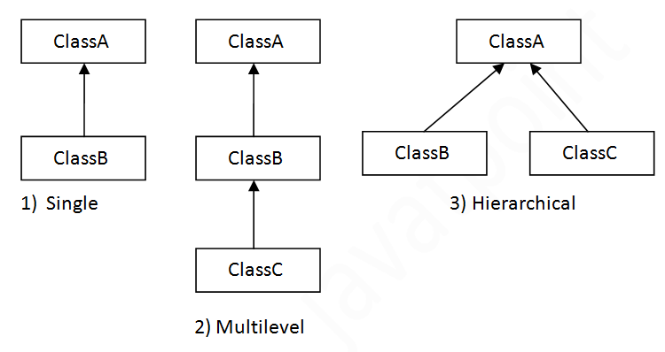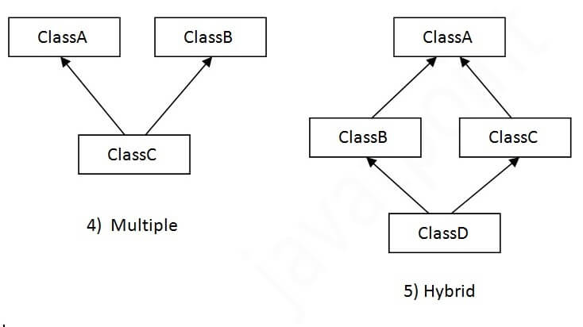

## **Why multiple inheritance is not supported in java?**

To reduce the complexity and simplify the language, multiple inheritance is not supported in java.

Consider a scenario where A, B, and C are three classes. The C class inherits A and B classes. If A and B classes have the same method and you call it from child class object, there will be ambiguity to call the method of A or B class.

Since compile-time errors are better than runtime errors, Java renders compile-time error if you inherit 2 classes. So whether you have same method or different, there will be compile time error.